Consider the column 'diesel'; what should the value for Car B be?

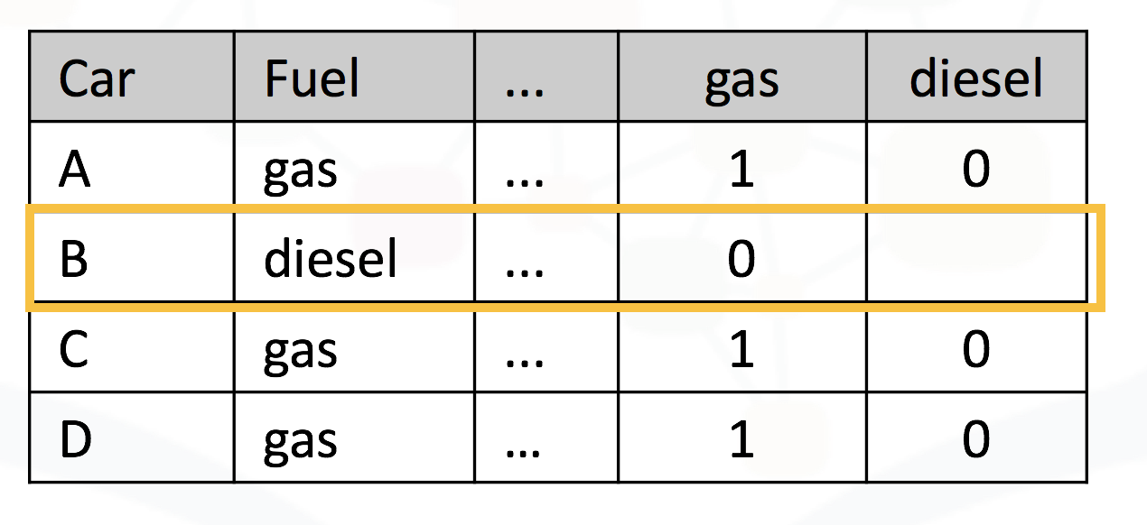



1



0

1 point